Joint exhibition stands of
the Federal Republic of Germany

agrofood West Africa (including food+bev tec, food+hospitality) - Int. Trade Show on Agriculture & Livestock, Food, Beverage & Packaging Technology and Food, Beverages & Hospitality
29. Nov. - 01. Dec. 2022, Accra, Ghana
 |  | Organiser | In cooperation with
IEC Inter Expo Consult GmbH  Torstraße 124  10119 Berlin  Germany |  | 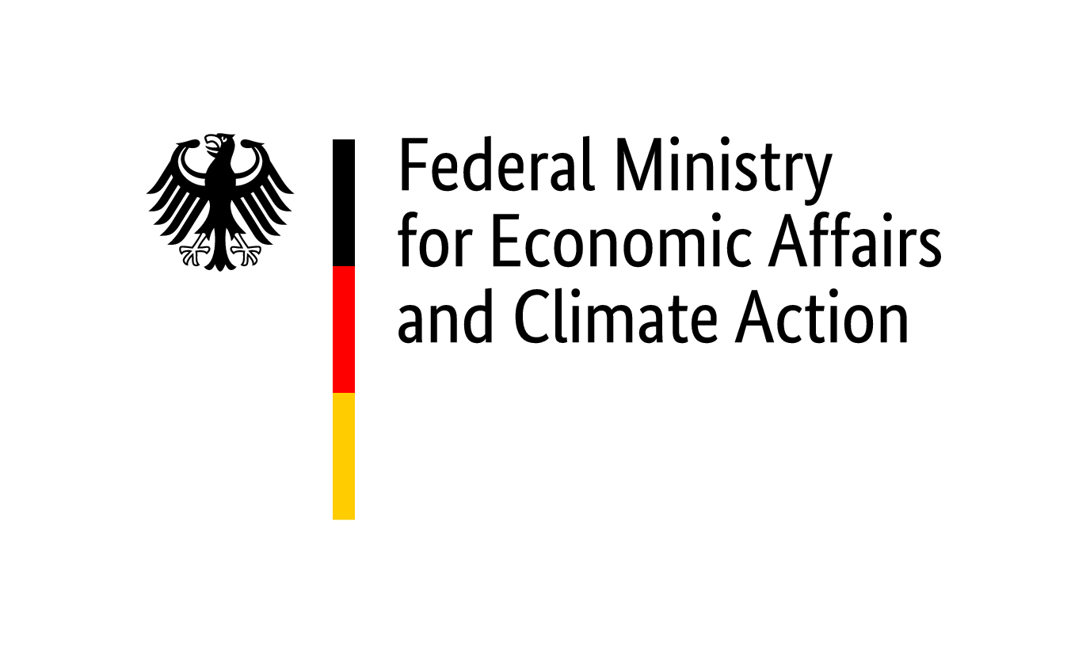 | 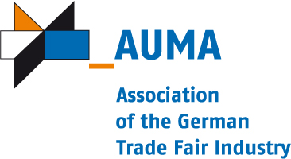
Realisation and exhibition management (implementation company
within the meaning of the General Conditions of Participation)
IEC Inter Expo Consult GmbH
http://www.iecberlin.de
Phone: +49 30 283939-0
Project manager:
Robin Witte
witte@iecberlin.de
Phone: +49 30 283939-15
Fax:
Registration | Closing date for registrations: 15. August 2022
We hereby register as participants at the above-mentioned participation.
Please note: Sub-exhibitors have to be registered separately.

1. Participant
 | Company name:
 | Street: |  | Contact partner:
 | Postcode & town: |  | Phone:
 | Federal state: |  | Fax:
 | VAT ID: |  | E-Mail:

2. Required exhibition space
All amounts indicated below are subject, where applicable, to statutory German and to statutory foreign taxation
2.1. Square meter
2.1.1. Participation up to and including the 4th time:
• m² hall space incl. stand construction 280,00 €/m² (up to 100 m², minimum area 9 m²)
• m² hall space without stand construction 220,00 €/m² (up to 100 m², minimum area 50 m²)
2.1.2. Participation for the 5th time or more:
• not applicable
2.1.3. Participation fee for space more than 100 sq.m. in the hall as well as for exhibitors, which cannot sign the attached declaration regarding double-funding respectively participation of the public sector (public authorities or public companies):
• m² hall space incl. stand construction 900,00 €/m² (minimum area 9 m²)
• m² hall space without stand construction 370,00 €/m² (minimum area 50 m²)

3. Mandatory Fee/s (do not depend on number of participations)
• Registration fee: 395,00 € / exhibition company
• Exhibitors presentation in the industry portal: 345,00 € / exhibition company

4. Connections (do not depend on number of participations)
• not applicable
5. Exhibition goods (At information stand: product range) Dimensions Weight
•
•
•

We have noted and acknowledged the General and Special Conditions of Participation. We undertake only to exhibit products which are produced according to No. 8 of the General Conditions for Participations of the Federal Republic of Germany at trade fairs and exhibitions abroad. We have completed and enclosed the registration appendices. We agree to the computer-aided recording, storage, and forwarding of company details to third parties. We declare, that insolvency proceedings have not been filed or opened for our assets or that we have not issued or are obliged to make a statutory declartion in accordance with sec. 802c Civil Code of Civil Procedure (ZPO) or sec. 384 of the German Tax Code (AO) 1977.

Place, date | Company stamp & legally binding signature

Enclosures:
• Appendix to registration form: Special Conditions of Participation
• Appendix to registration form: General Conditions of Participation
• Appendix to registration form: Declaration regarding double-funding respectively participation of the public sector (public authorities or public companies)
• Application of a sub-exhibitor by the main-exhibitor

Joint exhibition stands of the Federal Republic of Germany

agrofood West Africa (including food+bev tec, food+hospitality) - Int. Trade Show on Agriculture & Livestock, Food, Beverage & Packaging Technology and Food, Beverages & Hospitality
29. Nov. - 01. Dec. 2022, Accra, Ghana

Appendix to registration form
(Mandatory: please return with the registration form)

Exhibitor
 | Company:
 | Street: |  | Managing Director:
 | ZipCode, Town: |  | Commercial Reg.-No.:
 | Federal state: |  | District court:
 |  |  | Contact partner:

Declaration regarding double-funding respectively participation of the public sector
(public authorities or public companies)
With our registration for the official joint exhibition stands at the

agrofood West Africa (including food+bev tec, food+hospitality) - Int. Trade Show on Agriculture & Livestock, Food, Beverage & Packaging Technology and Food, Beverages & Hospitality
29. Nov. - 01. Dec. 2022, Accra, Ghana

I hereby declare/we hereby declare, that I/we do not receive any institutional fundings granted/covered by public resources.
I hereby declare/we hereby declare, that I/we do not receive any further public support out of project fundings for the participation at this trade fair/exhibition.
I hereby declare/we hereby declare, that my/our company is not a federal, state or municipal authority, is neither a state development institution nor any other legal entity under public law.
I hereby declare/we hereby declare that my/our company is not directly or indirectly majority-owned by a religious community/communities or by a legal entity/entities under public law.

Place, Date | Company stamp & legally binding signature

Firmengemeinschaftsausstellung der Bundesrepublik Deutschland

agrofood West Africa (including food+bev tec, food+hospitality) - Int. Trade Show on Agriculture & Livestock, Food, Beverage & Packaging Technology and Food, Beverages & Hospitality
29. Nov. - 01. Dec. 2022, Accra, Ghana
 |  |  |  | Veranstalter | In Kooperation mit
IEC Inter Expo Consult GmbH
Torstraße 124
10119 Berlin
Germany
 |  |  |  | Durchführung / Ausstellungsleitung (Durchführungsgesellschaft i.S.d. Allgemeinen Teilnahmebdingungen)
IEC Inter Expo Consult GmbH
http://www.iecberlin.de
Tel.: +49 30 283939-0
Projektleiter(in):
Robin Witte
witte@iecberlin.de
Tel.: +49 30 283939-15
Fax:
 | Anmeldung eines Unterausstellers durch den A U S S T E L L E R
1. Aussteller / Exhibitor
 | Firma: |  | zuständig:
 | Straße: |  | Telefon:
 | PLZ Ort: |  | Fax:
 | Bundesland: |  | E-Mail:

2. Unteraussteller / Sub-exhibitor
 | Firma: |  | zuständig:
 | Straße: |  | Telefon:
 | PLZ Ort: |  | Fax:
 | Bundesland: |  | E-Mail:

 |  | Internet:

3. | Pauschale für Unteraussteller  Die Pauschale für die Aufnahme eines Unterausstellers beträgt EUR 500,00 / Unteraussteller.  Aufnahme in den Internetauftritt und in die Broschüre  der Firmengemeinschaftsausstellung wird gewünscht ja nein  Das Formular zur Datenerfassung wird ausgefüllt vom Hauptaussteller Unteraussteller  Nach Erhalt der unterzeichneten Mitausstelleranmeldung wird dem Aussteller das Formular zur Datenerfassung  wie oben angegeben zugesandt.
4. | Zusätzliche obligatorische Gebühren des Veranstalters der Messe für Unteraussteller  • Registrierungsgebühr: 395,00 € / Unteraussteller  • Exhibitors presentation in the industry portal: 345,00 € / Unteraussteller
5. Ausstellungsgüter (Unteraussteller) Abmessungen/Dimension Gewicht/Weight
6. Anerkennung der Teilnahmebedingungen
Ich/Wir bestätigen hiermit rechtsverbindlich, dass wir die Allgemeinen und Besonderen Teilnahmebedingungen für Beteiligungen des Bundes an Messen und Ausstellungen im Ausland anerkennen.
Ort, Datum | Firmenstempel und Unterschrift des Unterausstellers
Ort, Datum | Firmenstempel und Unterschrift des Ausstellers

Joint exhibition stands of the Federal Republic of Germany

agrofood West Africa (including food+bev tec, food+hospitality) - Int. Trade Show on Agriculture & Livestock, Food, Beverage & Packaging Technology and Food, Beverages & Hospitality
29. Nov. - 01. Dec. 2022, Accra, Ghana
 |  |  |  | Organiser/ | In cooperation with
IEC Inter Expo Consult GmbH
Torstraße 124
10119 Berlin
Germany
 |  |  |  | Realisation and exhibition management implementation company within the meaning of the General Conditions of Participation)
IEC Inter Expo Consult GmbH
http://www.iecberlin.de
Phone: +49 30 283939-0
Project manager:
Robin Witte
witte@iecberlin.de
Phone: +49 30 283939-15
Fax:
 | Application of a sub-exhibitor by the E X H I B I T O R
1. Aussteller / Exhibitor
 | Company: |  | Person in charge:
 | Address: |  | Phone:
 | ZipCode Town: |  | Fax:
 | Bundesland/Country: |  | E-Mail:

2. Unteraussteller / Sub-exhibitor
 | Company: |  | Person in charge:
 | Address: |  | Phone:
 | ZipCode Town: |  | Fax:
 | Bundesland/Country: |  | E-Mail:

 |  | Internet:

3. | Fee for sub-exhibitors  For registration of a sub-exhibitor a registration fee of EUR 500,00 / sub-exhibitor will be due.  Admission to the internet presence and brochure  to the German joint stand is requested yes no  The data collection form will be filled in by the main-exhibitor the sub-exihibitor  As soon as we have received the application for co-exhibitors we will send you the data collection form as stated above.
4. | Additional mandatory fee/s for a sub-exhibitor charged by the organizer of the trade fair  • Registration Fee: 395,00 € / sub-exhibitor  • Exhibitors presentation in the industry portal: 345,00 € / sub-exhibitor
5. Exhibits (Sub-exhibitor) Abmessungen/Dimension Gewicht/Weight
6. Confirmation of the Terms of Conditions
I/We accept the General and Special Conditions of Participation of the Federal Republic of Germany at trade fairs and exhibitions abroad.
Place, Date | Company stamp and signature of the sub-exhibitor
Place, Date | Company stamp and signature of the exhibitor

